

NAME – VAIBHAV KHARE

EMAIL ID – [VAIBHAV.KHARE96@GMAIL.COM](mailto:VAIBHAV.KHARE96@GMAIL.COM)

QUESTION 1 – Add a 10GB to the CentOS.

Ans – Adding 10GB space -

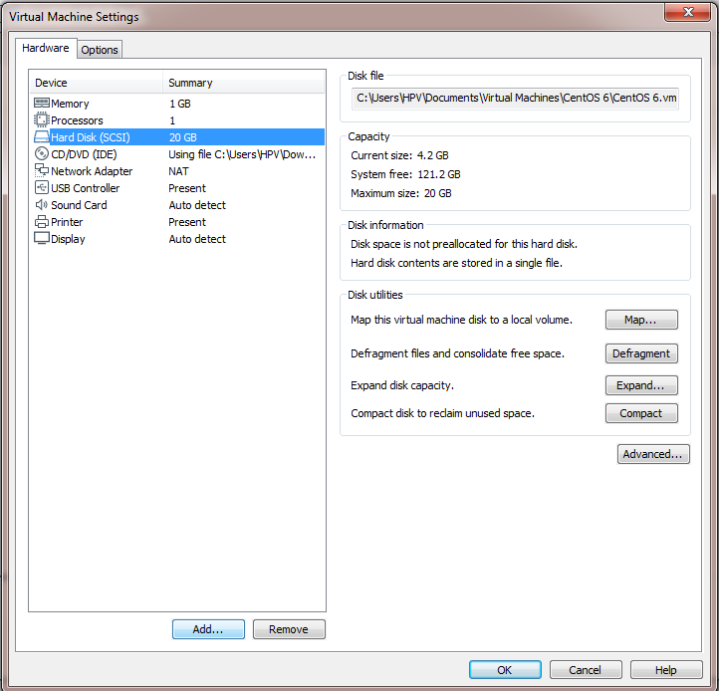

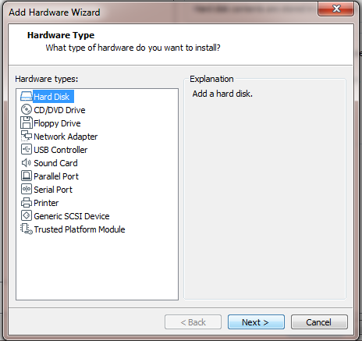

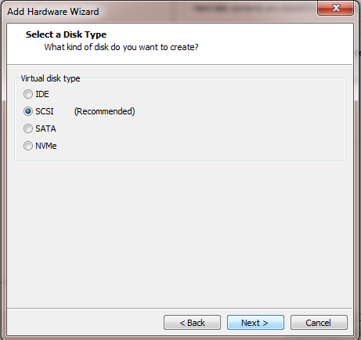

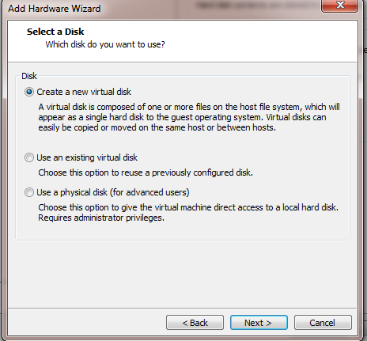

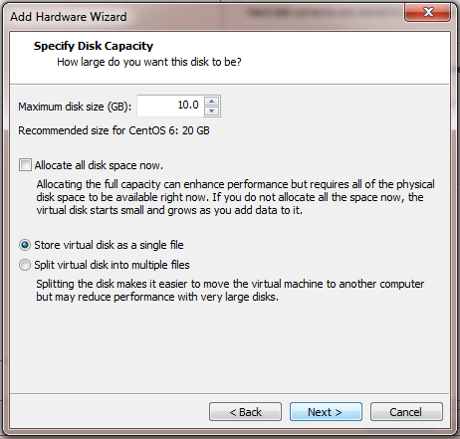

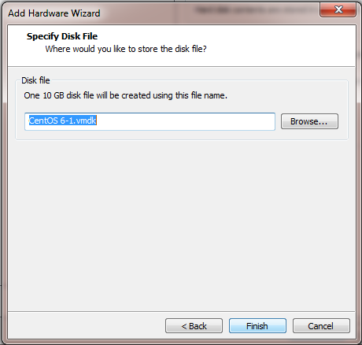

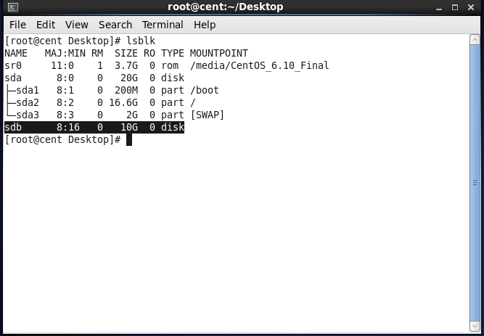

Question 2 – Create 2 Partitions 4GB and 6GB of space respectively.

Ans – Creating 2 Partitions of size 4GB and 6GB . space -

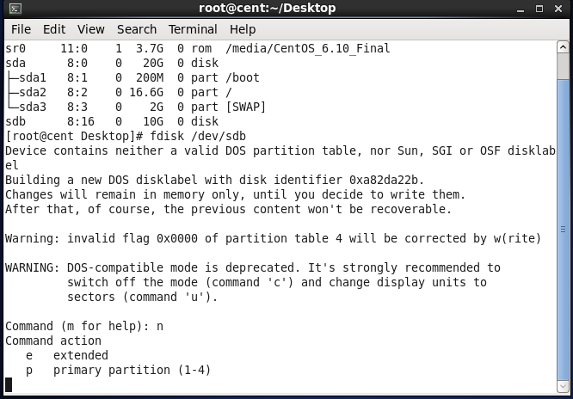

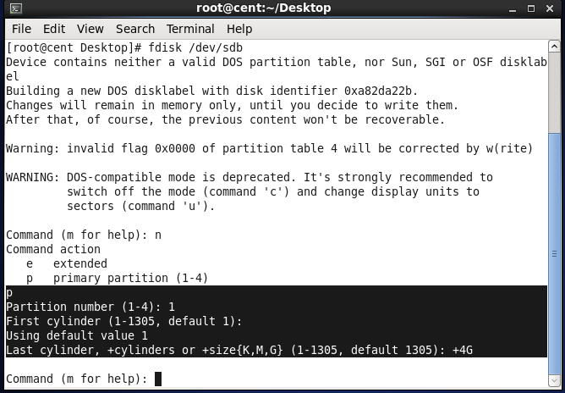

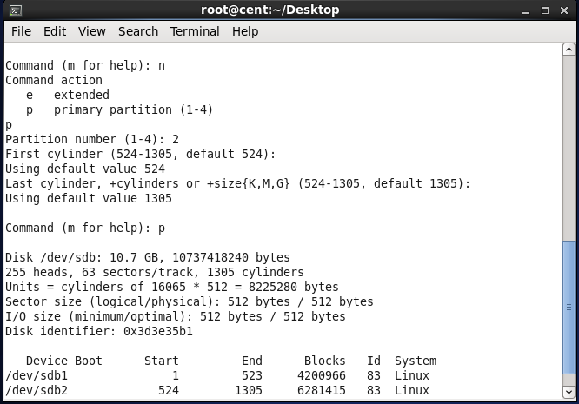

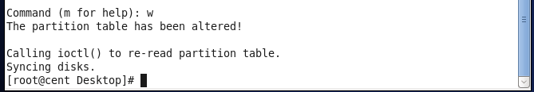

Question 3 – Format 4GB with xfs and 6GB with ext4 file system.

Ans – Formatting 4GB and 6GB respectively -

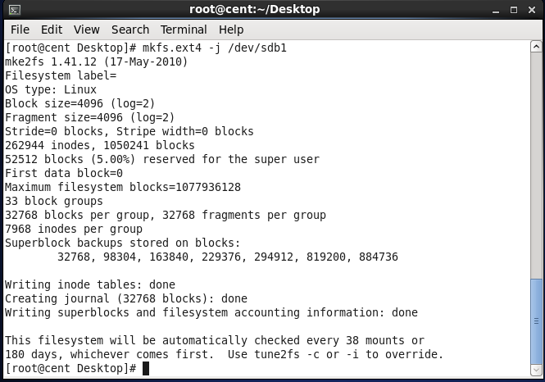

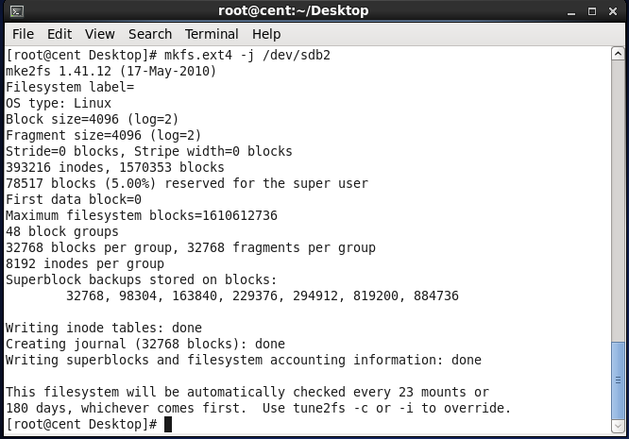

Question 4 – Mount 4GB and 6GB in /data and . /music directory respectively.

Ans – Making /data and /music directory and then . mounting it with 4GB and 6GB respectively -

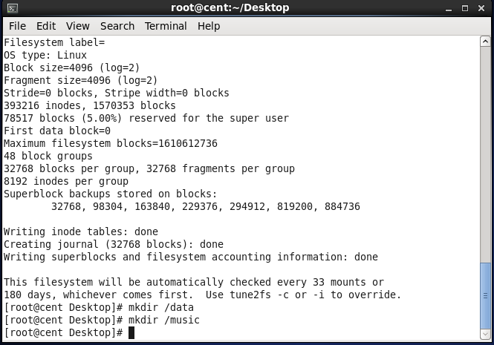

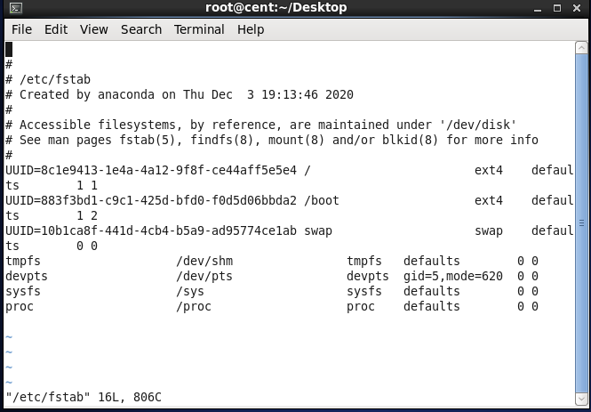

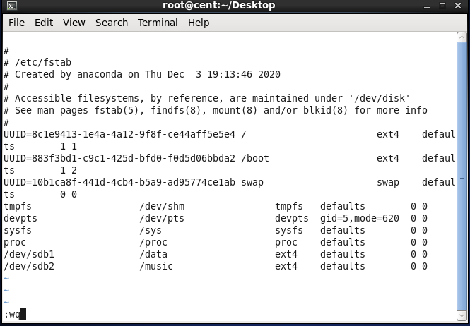

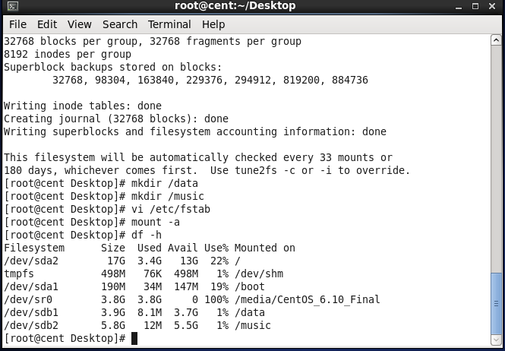

Question 5 – Create one file of 1GB in each of . the mount point created above.

ANS – Creating file of 1GB -

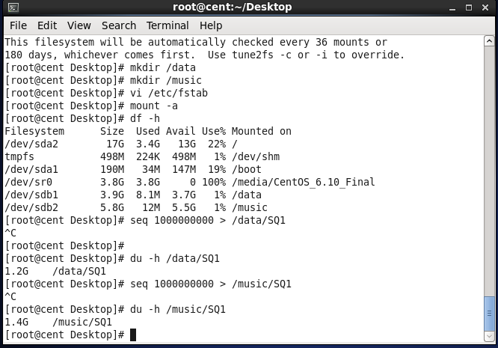

Question 6 – Verify the disk consumption and . disk space free in the mounted partitions.

ANS – Verifying the disk consumption after . . . creating file of 1GB -

